Redhat System Adminstration I: Lab 2 solution

Mohamed Ahmed Mohamed Al-Soufie

13th-Jan-2025

11.Remove dir11 in one-step. What did you notice? And how did you overcome that?

A- The directory failed to be deleted because it's not empty.

To delete un-empty directories we have to use the "rm -r <directory-name>" command.

12.Copy the /etc/passwd file to your home directory making its name is mypasswd.

cp /etc/passwd ~/mypasswd

13.Rename this new file (which at your home) to be oldpasswd

mv ~/mypasswd ~/oldpasswd

14.Write the command which display the man page of the passwd file”/etc/passwd”.

man passwd

15.Write the command which display a list of all the commands that contain the keyword “passwd” in their man/manual page.

man -k passwd

16.You are in /usr/bin, list four ways to go to your home directory

1-cd ~/

2-cd -/

3-

cd .. (/usr)

cd .. (/)

cd /home/<my-user-name>

4- cd /home/<my-user-name>

17.The output of the command pwd was /home/<your_user_name>. Write the absolute and relative path for the file /etc/passwd

absolute: /etc/passwd

relative: ../../etc/passwd

18.Show the total directory size of /home/<your_user_name>.

df -h ~

or

df -h /home/<my-user-name>

19.List all files at your /etc which end with .config

ls /etc/*.config

20.Create a folder called /tmp/myconfig and copy to it all .config files from etc to it

mkdir /tmp/myconfig

cp /etc/*.config /tmp/myconfig/

21.Remove the directory /tmp/myconfig

rm -r /tmp/myconfig/

22.Display lines 1 to line 5 of /etc/passwd file

more -5 /etc/passwd

23.Using vi write your CV in the file /tmp/mycv. Your CV should include your name, age, school,

college, experience,...

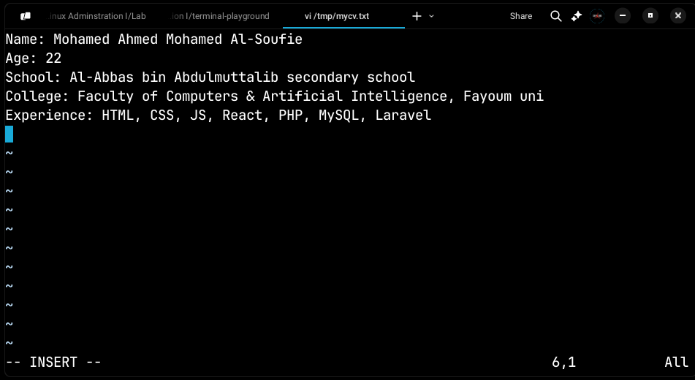

24.Open /tmp/mycv file using vi command then: Without using arrows state how to:

a. Move the cursor down one line at time.

<j>

b. Move the cursor up one line at time.

<k>

c. Search for word age

</age>

d. Step to line 5 (assuming that you are in line 1 and file is more than 5 lines).

<5G>

e. Delete the line you are on

<dd>

f. Delete line number 5.

<:5d>

g. How to step to the end of line and change to writing mode in one-step.

<A>

25.Create a user account with the following attribute

● username: islam

● Fullname/comment: Islam Askar

sudo useradd -c "Islam Askar" -md /home/islam-askar islam

● Password: islam

sudo passwd islam

<islam> Enter

<islam> Enter

26.Create a user account with the following attribute

● Username: baduser

● Full name/comment: Bad User

sudo useradd -c "Bad User" baduser

● Password: baduser

sudo passwd baduser

<baduser> Enter

<baduser> Enter

27.Create a group called pgroup with group ID of 30000

sudo groupadd -g 30000 pgroup

28.Create a group called badgroup

sudo groupadd badgroup

29.Add islam user to the pgroup group as a supplementary group

sudo usermod -aG pgroup islam

30.Log out and log in by another user

su - islam

<islam> Enter

31.Modify the password of islam's account to password

sudo passwd islam

<password> Enter

<password> Enter

32.Modify islam's account so the password expires after 30 days

sudo chage -M 30 islam

33.Lock bad user account so he can't log in

sudo chage -E 2025-01-12 baduser

or

sudo passwd -l baduser

34.Delete bad user account

(used -r to delete his home dir as well.)

sudo userdel -r baduser

35.Delete the group called badgroup.

sudo groupdel badgroup